1. Check the DATE on computer (can’t be too far off)
2. Possibly clear the QM file on the local computer (client; see separate instructions)
3. Make sure the QuizMachine version is at least 4.1.x, but 4.1.y29 is better and must be used for Windows 7 and a USB interface box.
4. Load QM file using the scoresheet function/”Import Names/Schedules” and that the “Use Imported Names” box is checked.

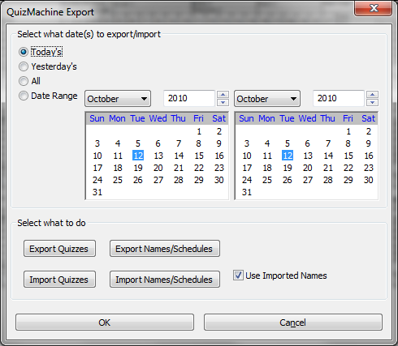

**CHECK QM Options** (either from Lineups or Setup)

Rules/Method: Tournament (Critical)

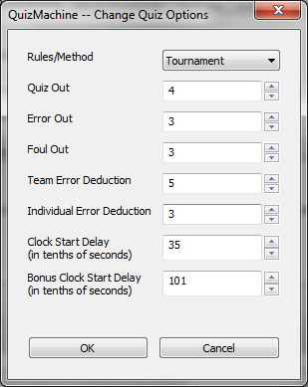Parameters:

Quiz Out = 4

Error Out = 3

Foul Out = 3

Team Error Deduction = 5

Individual Error Deduction = 3

Clocks = leave as is

(the picture below is the default)

**ENTER QM “Create a New Quiz” OPTIONS** (from Lineups)

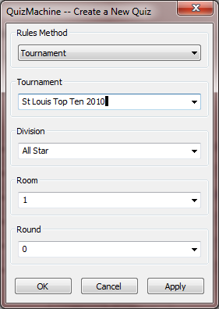

1

Rules Method = Tournament

Tournament = Whatever you want it to be

Division = Whatever you want it to be

Room = 1 (just the room number from 1-xx or whatever you want)

Round = 1 (one; I do not recommend using the schedule part of the file)

Click OK

A message indicating that the previous round was not complete may be displayed. Click OK.

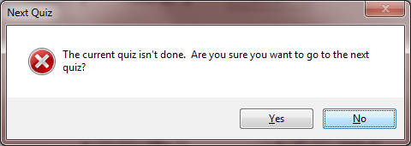

**AT THE LINEUPS SCREEN**, click next quiz. It should display Round 1 and you should be able to drop down team members. Check the schedule to make sure the right teams are in this room.

From the QuizMachine Properties window, select Server/Sneakernet; make these entries:

1. Make sure the “Use Imported Names” box is checked.
2. Make sure the “Use the Server:” check box is **NOT** checked.
3. Make sure the “Check in with the Server” is **NOT** checked.

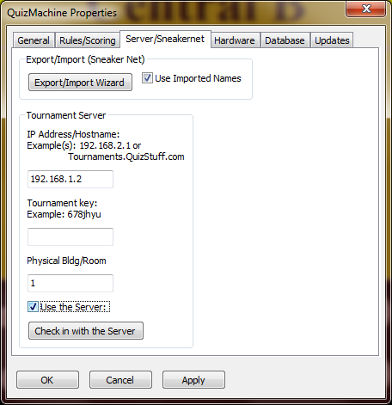

At this point the client computer should be ready.